Specifications

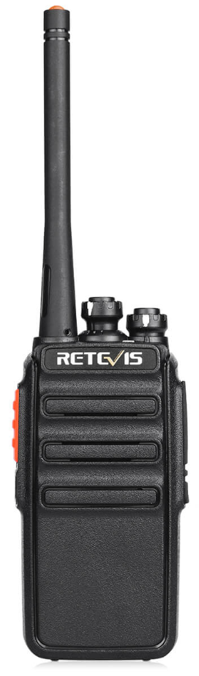
Contents
General 3
General Radio Specification 3
Receiver 3
Transmitter 3
Gallery 5

General

General Radio Specification
Name | RT24
Brand | Retevis
Channels | 16
Frequency Range | 149.0250-149.1125MHz  PMR 446
Battery
Working Voltage | 3.7 DC
Effective Radiated Power | Low: 0.5W  High: 2.0W
Operating Temperature | -10ºC to +50ºC
Antenna | Fixed
Antenna Impedance | 50Ω
Scan | Yes
Vox | Yes
Battery Save | Yes
Bandwidth | 12.5Khz
CTCSS/DCS | Yes
Low Battery Alarm | Yes
Busy Channel Lock | Yes
Working Mode | Simplex
Time-out-Time (TOT) | 180s
Voice | English  Chinese
Squelch Adjustment | Yes
Weight (Including Battery) | 193g
PC Program Protection | Yes
Dimensions | 230*62*34mm

Receiver
RF Sensitivity | ≤0.2µV
Occupied Bandwidth | ≤16KHz
Selectivity | ≥65dB
Intermediation | ≥55dB
Audio Power | >500mW
Audio Distortion | ≤5%
Frequency Stability | 5ppm
Current | Standby: 55mA  Working: 150mA
Audio Response | (300-3000Hz):+7~-12.5dB

Transmitter
Modulation Type | 16K¢F3F
Spurious Radiation | ≤7.5µW
Modulated Noise | <-40dB
Modulation Distortion | <5%
Frequency Stability | 5ppm
Max. Fr Deviation | ≤±5KHz
Current | ≤1200mA
Audio Response | (300-3000Hz):+6.5~-14dB
Adjacent CH. Power | ≥65dB
Intermediation Sensitivity | 8-12mv

Gallery

Description | Image
Front | 

